Dance Music Icon Armin van Buuren Announces Virtual Reality Concerts in Sensorium Galaxy

The GRAMMY-nominated DJ & producer prepares to take his DJ sets to a new dimension, announcing a series of performances in TIDAL-backed social VR platform Sensorium Galaxy.

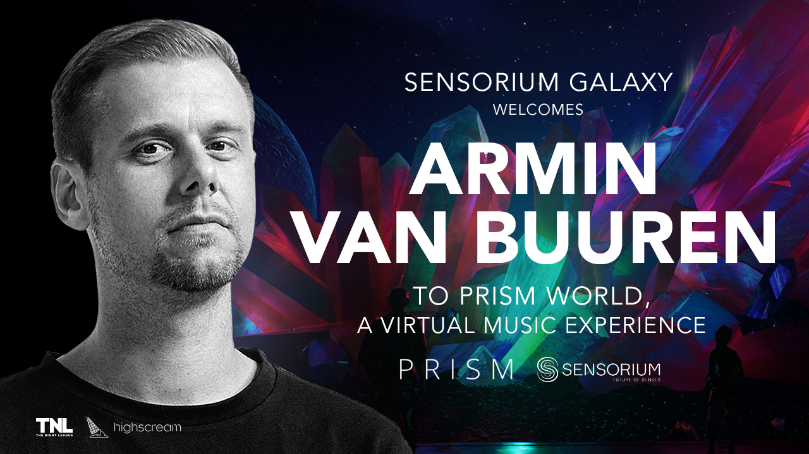

Chart-topping artist, music tastemaker and the only DJ in history to top the World’s Best DJs ranking on 5 occasions, Armin van Buuren will share his music in PRISM, a groundbreaking new virtual world inside Sensorium Galaxy. The TIDAL-backed social VR platform that redefines the way people interact with each other and experience the arts.

Global dance music icon Armin van Buuren is a true legend of the electronic music industry. He is a regular headliner at world-famous music events such as EDC Vegas, Tomorrowland, Ultra Music Festival, alongside his own internationally-renowned residency at Hï Ibiza, the trance figurehead is also well known for his entrepreneurial flair. From co-founding Armada Music, one of the world’s most successful dance music labels, to growing his weekly radio show — A State of Trance — into the world's largest trance community with over 40 million listeners, the GRAMMY-nominated artist continues to innovate and assure his position as of the most influential figures in EDM worldwide.

Having conquered the dance music world, Armin van Buuren has now set his sights on the virtual world, joining forces with Sensorium Corporation, together with The Night League & High Scream, to announce a series of exclusive DJ performances in PRISM, the music world located within the alternate universe of Sensorium Galaxy.

Sensorium will create a photorealistic avatar of Armin van Buuren using state-of-the-art motion capture technology, which will then be used to front the Dutchman’s performances once the platform launches early next year.

The concept of PRISM is developed with the artistic guidance of Yann Pissenem, CEO & Founder of The Night League and the mastermind behind award-winning nightclubs Hï Ibiza and Ushuaïa Ibiza. The environment and landscape of PRISM are ever-evolving, under the influence of sound frequencies and the strength of a sound wave, making it a perfect place for music events of a galactic scale.

Armin van Buuren: “The virtual environment that Sensorium is building allows artists to set their imagination free and create unprecedented shows that are impossible in real life. By not being subjected to the laws of physics and the boundaries of the real world, I can develop performances where the immersive environment becomes a part of the show, and my fans from all over the world can feel the real vibes of live shows and become active participants of the event. Utilising Sensorium's technology, this will be the closest thing fans will experience to a real show, as well as a new form of art. Can’t wait for this”

To give artists a chance to engage with their audiences at an emotional level, Sensorium uses AAA graphics and advanced social mechanics enabling deeper connections between participants, eliminating social isolation — one of the biggest challenges for current VR platforms. In addition to being able to share the experience with friends, participants will be able to move through the air, experience the show through the eyes of the artist, get a digital autograph, or even a virtual selfie.

Yann Pissenem: “Armin van Buuren is one of the true pioneers of dance music. He has dedicated his entire life to his passion and it is an honour to have him join our project and take his work to a whole new level, a new reality. The fact that Armin is joining other recently announced, huge calibre artists like David Guetta and Carl Cox clearly speaks to where the entertainment industry is heading. Sensorium’s PRISM is set to become the top virtual destination for music enthusiasts around the globe. Now, the intensity of Armin’s real-life performances will reach millions regardless of their physical location.”

The public release of Sensorium Galaxy is scheduled for H1 2021. Whether it is by wearing a VR headset, using PCs, or simply tuning in for streaming with their Macs or mobile devices, users from all over the world will be able to experience the intensity of world-class shows in Sensorium Galaxy

Press Kit
Photos and videos are available in the Sensorium Galaxy Press Kit

About Sensorium Galaxy

Sensorium Galaxy is a multi-user social VR platform that rethinks the way people interact with each other and experience the arts. In the alternate universe of Sensorium Galaxy, users immerse themselves in exciting new worlds to get together with their loved ones, meet new people, and take part in unique virtual activities.

The Galaxy is being built in partnership with world-known artists, producers, and entertainment companies. Among them are Yann Pissenem, the creator of the world-leading nightlife hubs Ushuaïa Ibiza and Hï Ibiza, and music and entertainment streaming service TIDAL owned by globally-acclaimed artists such as JAY-Z, Lil Wayne, Rihanna, Daft Punk, and others.

In essence, Sensorium Galaxy is the evolution of social networking taking users far beyond today’s one-dimensional digital experiences.

The platform will be compatible with the most popular VR headset brands, as well as accessible on PC, Android, and iOS devices. It will go live in H1 2021.

Website: https://sensoriumgalaxy.com/

About Sensorium Corporation

Founded in 2018 with the sole support of Forbes-listed billionaire Mikhail Prokhorov, Sensorium Corporation oversees the technological and business development of the Sensorium Galaxy platform and supplies it with a wide range of events and experiences through top-tier global content partnerships.

Consisting of professionals from a wide array of fields, Sensorium’s management team guarantees that the technological collaboration and strategic partnerships are always directed toward the attainment of Sensorium’s most relevant contribution to the virtual reality landscape—to make it fully social.

Since its foundation, Sensorium Corporation has raised over $100 million in private investments, making it one of the world’s best-funded startups in the VR space.

Website: https://sensoriumxr.com/

About Yann Pissenem

Born in Nancy, France, Yann Pissenem is a leading nightlife entrepreneur based in Ibiza, Spain. He is the founder, CEO and owner of Ushuaïa Ibiza and Hï Ibiza, and with his event production company The Night League, he is responsible for the organisation, programming, bookings, artist relations, creative direction, production, marketing, operations as well as the day to day running of two of the world’s leading nightclubs.

From May to October, Yann and The Night League program and run all aspects of over 250 shows which take place both day and night, continuously for five months. 2019 saw over 1.5million clubbers from all corners of the globe passed through his doors. Throughout the year Yann promotes global tour dates for his event brands including ANTS and Fun Radio Ibiza Experience. As such, Pissenem can be counted as one of the true figureheads of the global nightlife scene.

Website: www.thenightleague.com

