DIMITRI VEGAS & LIKE MIKE ANNOUNCE VR PERFORMANCES
AT SENSORIUM GALAXY

Award-winning DJs Dimitri Vegas & Like Mike are the latest artists announced to perform a series of shows on the virtual stages of PRISM World, the extraordinary music hub for virtual reality events located within Sensorium Galaxy. Launching in early 2021, the social VR Platform will also host performances from previously announced headliners such as David Guetta, Carl Cox & Armin van Buuren.

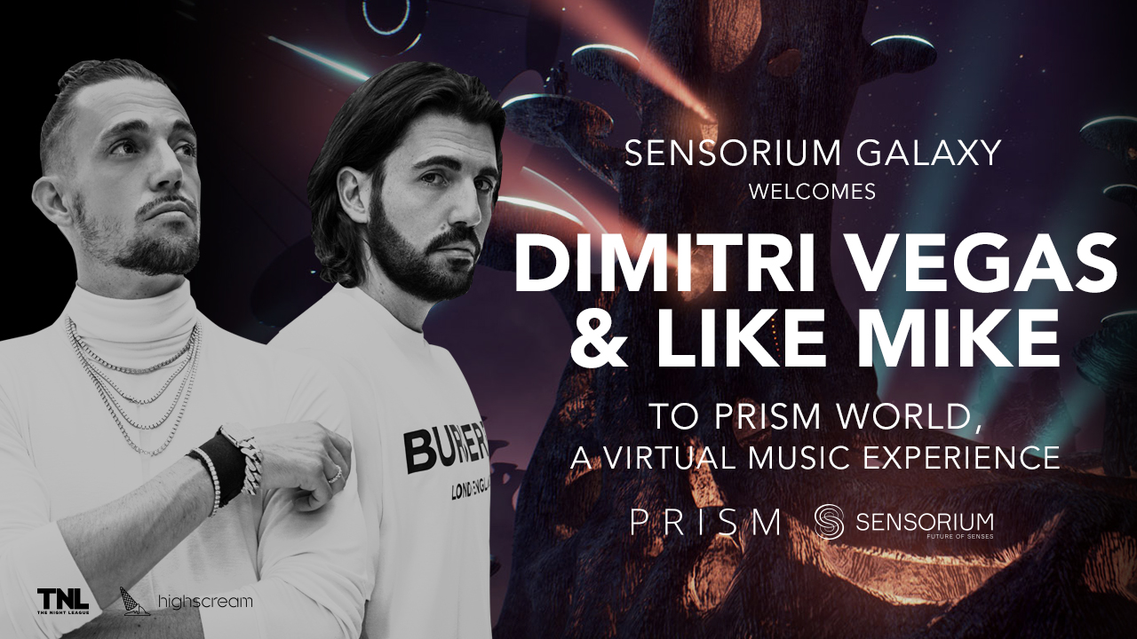

Los Angeles, California, November 19, 2020 - Dimitri Vegas & Like Mike are set to produce and host a series of high-power DJ sets in Sensorium Galaxy. The dance music duo joins a growing roster of world-leading electronic artists, including David Guetta, Armin Van Buuren and Carl Cox, who are set to share their music in PRISM, the social VR platform’s electronic music hub, which launches next year.

Dimitri Vegas & Like Mike are among the most famous names in electronic music. Known for their epic stage performances, the Belgian brothers electrifying live combination of DJ sets and crowd-busting MC’ing has seen them perform around the world at leading clubs and festivals including Tomorrowland, Ushuaïa Ibiza and EDC Las Vegas. As well as ranking #1 in the 2019 and 2015 list of Top 100 DJs by DJ Mag, these award-winning artists are also known for their chart-topping dance anthems and huge remix cuts, including A-list collaborations with American singer-songwriter Ne-Yo, David Guetta & Kiiara, and Daddy Yankee & Natti Natasha.

In preparation for their performances on PRISM, the world’s most sophisticated venue for virtual reality music events, the duo will be digitized using avant-garde motion capture technology to create photorealistic avatars. These avatars will be used for all of their performances inside Sensorium Galaxy, which is scheduled to launch in early 2021.

Dimitri Vegas & Like Mike: “We’re really excited to take part in a project that’s pushing the boundaries of communications and entertainment. For us, performing is all about connecting with our fans and Sensorium Galaxy gives us a chance to do this regardless of where we all are in the world. Until now, such experiences were only available at real-life events, so we can’t wait to bring the same kind of high energy performance, high level production that we’re known for into the virtual world”.

This exclusive collaboration is a result of joint efforts between Sensorium Corporation and renowned creative agencies The Night League & High Scream to make the best real-life entertainment globally available through virtual reality.

“The unrivalled energy that Dimitri Vegas & Like Mike bring to the stage has cemented their place amongst the world’s top DJs. Always ahead of the latest music trends and the creative minds behind countless dancefloor anthems, it is essential they join us as part of Sensorium Galaxy. I can’t wait to see how their avatars will take crowds to the next level and create some jaw-dropping shows in the immersive virtual world of PRISM.” - Yann Pissenem, CEO & Founder of The Night League.

Sensorium Galaxy is focused on revolutionizing digital communication. Apart from delivering AAA graphics, the platform offers highly realistic interactions between users thanks to both verbal and non-verbal communication features. Multi-user support also allows participants to share activities with friends, family, and other people from any corner of the planet.

The public release of Sensorium Galaxy is scheduled for early 2021. Whether it is by wearing a VR headset, using PCs, or simply tuning in for streaming with their Macs or mobile devices, users from all over the world will be able to experience the intensity of world-class shows in Sensorium Galaxy. Find out more and keep up with all of the latest developments at sensoriumgalaxy.com.

Press Kit
Photos and videos are available in the Sensorium Galaxy Press Kit

About Sensorium Galaxy
Sensorium Galaxy is a multi-user social VR platform that rethinks the way people interact with each other and experience the arts. In the alternate universe of Sensorium Galaxy, users immerse themselves in exciting new worlds to get together with their loved ones, meet new people, and take part in unique virtual activities.

The Galaxy is being built in partnership with world-known artists, producers, and entertainment companies. Among them are Yann Pissenem, the creator of the world-leading nightlife hubs Ushuaïa Ibiza and Hï Ibiza, and music and entertainment streaming service TIDAL owned by globally-acclaimed artists such as JAY-Z, Lil Wayne, Rihanna, Daft Punk and others.

In essence, Sensorium Galaxy is the evolution of social networking taking users far beyond today’s one-dimensional digital experiences.

The platform will be compatible with the most popular VR headset brands, as well as accessible on PC, Android, and iOS devices. It will go live in H1 2021.

Website: https://sensoriumgalaxy.com/

About Sensorium Corporation
Founded in 2018 with the sole support of Forbes-listed billionaire Mikhail Prokhorov, Sensorium Corporation oversees the technological and business development of the Sensorium Galaxy platform and supplies it with a wide range of events and experiences through top-tier global content partnerships.

Consisting of professionals from a wide array of fields, Sensorium’s management team guarantees that the technological collaboration and strategic partnerships are always directed toward attainment of Sensorium’s most relevant contribution to the virtual reality landscape—to make it fully social.

Since its foundation, Sensorium Corporation has raised over $100 million in private investments, making it one of the world’s best-funded startups in the VR space.

Website: https://sensoriumxr.com/

